Kortext login for first time users

1. Click on the Online access link in the catalogue or access the ebook from your reading list or via a direct link.
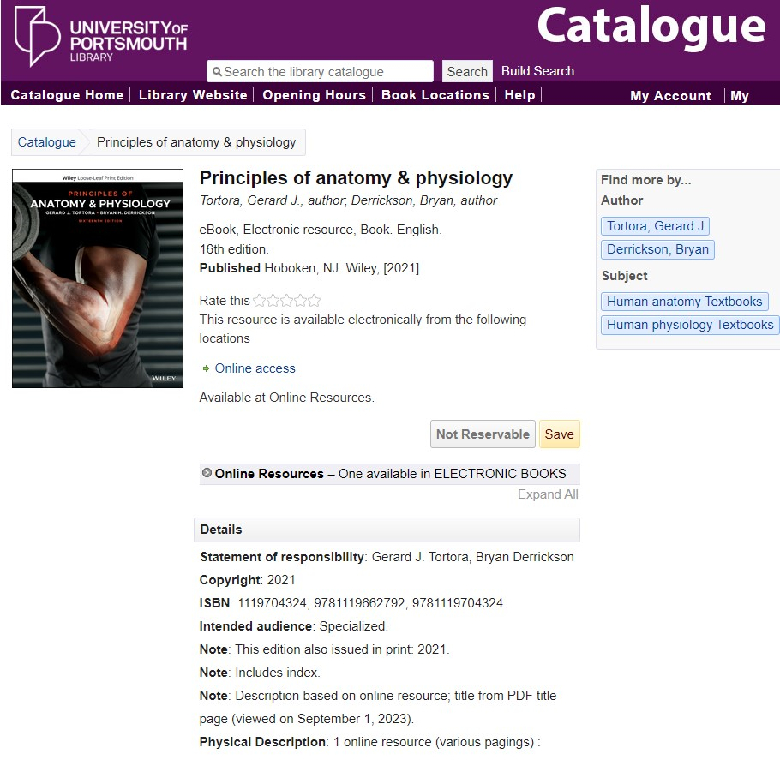

2. Enter your University login details. You may have to do this twice.
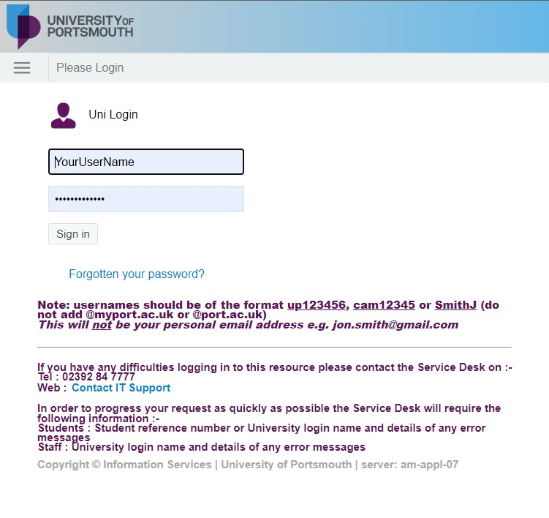

3. You must register for an account. Enter your University email address and make up a password of your choosing. Then click on Access my textbook.
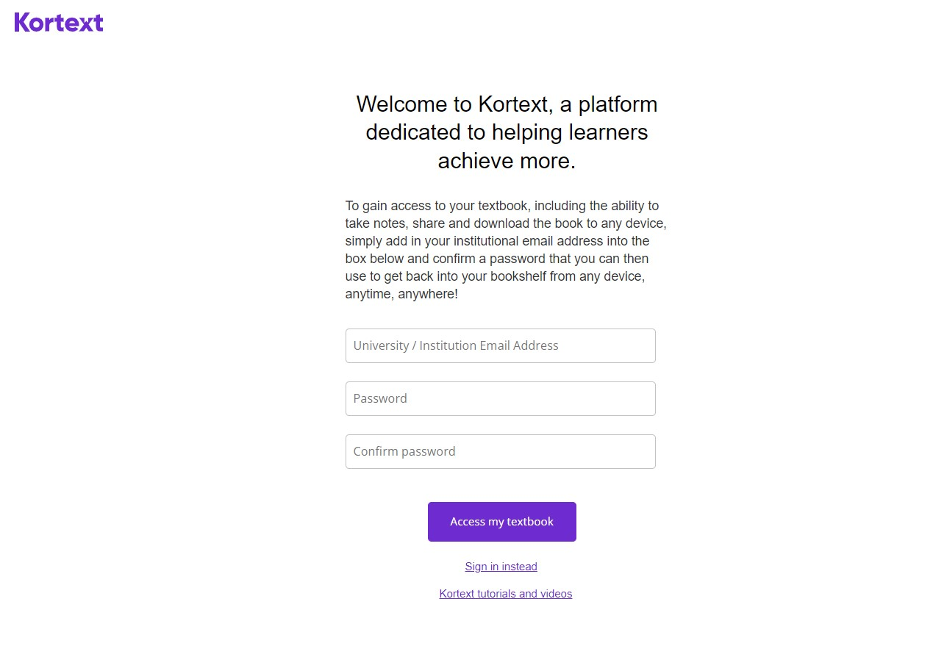

4. Agree to the terms and conditions and click on Sign in.
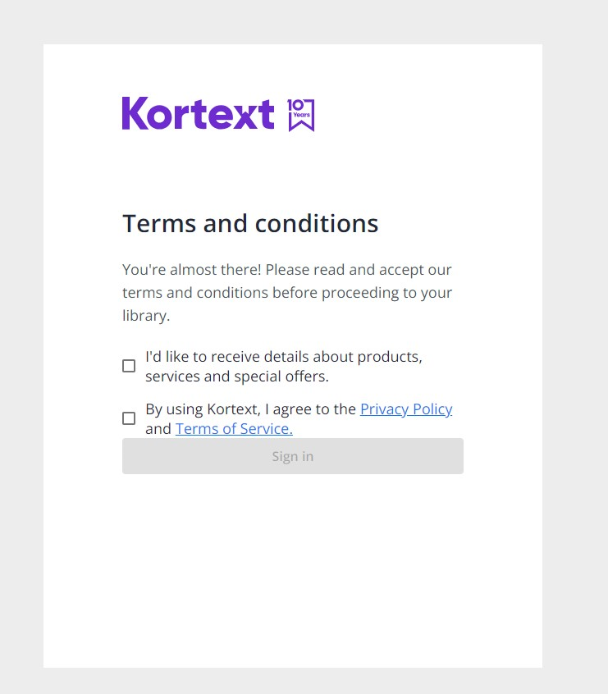

5. This will take you into the book.
